Appendix III. Weak-label corpus construction workflow
- Purpose and scope
This appendix documents how the weak ACOS-labelled corpus was constructed for large-scale supervised training within the case implementation. Its purpose is to explain, in operational terms, how sampled city-level review subsets were created, how those sampled reviews were converted into provisional ACOS-coded observations through an LLM-assisted weak-labelling workflow, and how the resulting retained weak-label corpus was organised at the review level. Whereas Appendix II reports the fixed ACOS labelling protocol itself, the present appendix documents how that protocol was applied at scale under a stable and reproducible workflow. In particular, the appendix reports the sampling procedure used to construct the input subsets (Figure 1), the LLM-assisted weak-labelling and validation workflow used to generate provisional ACOS observations (Figure 2), and the principal characteristics of the final retained weak-label JSONL corpus used in subsequent modelling.
- Sampling procedure
Weak-label generation was carried out on sampled city-level review subsets rather than on the full review corpus directly. As shown in Figure 1, the sampling design followed a two-stage stratified workflow. The procedure began by setting a target sample size equal to 10% of each city-level dataset, together with a minimum requested coverage of three reviews per restaurant. In Stage A, restaurant-level quotas were allocated in a feasibility-aware manner so that smaller restaurants were not excluded while the global city-level target remained attainable. More specifically, the procedure first determined a feasible lower bound per restaurant and then distributed the remaining sample slots across restaurants in proportion to residual capacity.
------------------Insert Figure 1 around here------------------
Once the restaurant-level quotas had been determined, Stage B sampled reviews within each restaurant using a stratified design. At this stage, within-restaurant strata were formed on the basis of the review characteristics used in the sampling workflow, after which a Neyman-style allocation was applied across strata before reviews were sampled from each stratum. The sampled reviews from all restaurants were then combined into a city-level subset. A final hard size-enforcement step adjusted the realised subset, where necessary, so that the final sample size matched the target exactly without taking any restaurant below its allocated lower bound.

The procedure was applied separately to the four city-level review datasets corresponding to Bilbao, Vitoria, San Sebastián, and Pamplona. Across these four sampled subsets, the final weak-labelling input comprised 21,715 reviews in total: 5,536 from Bilbao, 5,083 from Vitoria, 5,882 from San Sebastián, and 5,214 from Pamplona. These sampled reviews covered 379 restaurants in total, with 100 restaurants in Bilbao, 98 in Vitoria, 88 in San Sebastián, and 93 in Pamplona. In aggregate, these sampled subsets yielded the 21,715 reviews in 379 restaurants used as input for weak labelling.
- LLM-assisted weak-labelling workflow for ACOS observational coding
Weak ACOS labels were generated through an LLM-assisted weak-labelling workflow for ACOS observational coding, as summarised in Figure 2. In this workflow, the sampled city-level review subsets served as the input corpus, and a fixed coding configuration was applied before model inference. More specifically, the workflow fixed the ACOS coding protocol documented in Appendix II, constructed each review-level input as the prompt prefix plus the review text, and used GPT-5 Thinking as the large language model for coding. The prompt used is reproduced below. To support scalable processing, the workflow also used concurrent execution with up to eight worker threads.
Extract ACOS tuples as a valid JSON list-of-lists.
Output format must be exactly [[ASPECT, CATEGORY, OPINION, SENTIMENT], ...].
Every inner list must contain exactly four double-quoted strings.
Each tuple must be a facet-linked textual observation directly supported by explicit review text.
Treat each ACOS tuple as an admissible micro-level observation rather than a whole-review summary.

Allowed CATEGORY values are exactly FOOD#QUALITY, SERVICE#GENERAL, and AMBIENCE#GENERAL.
Copy one of those category strings exactly; do not invent, vary, or paraphrase category names.

Use FOOD#QUALITY for evaluative evidence about the food consumed, including taste, freshness, temperature, presentation, menu variety, and healthy options when explicitly mentioned.
Use SERVICE#GENERAL for evaluative evidence about employee service during the service encounter, especially attitudes, interpersonal interactions, helpfulness, promptness, and communication with customers.
Use AMBIENCE#GENERAL for evaluative evidence about the restaurant's physical environment, including decor, artifacts, spatial layout, and ambient conditions such as noise, temperature, lighting, and cleanliness.

Sentiment must be one of: very negative, negative, neutral, positive, very positive.
Only output tuples directly supported by explicit text evidence.
Do not infer latent scores, overall restaurant quality, or unstated facet evaluations.
Do not add a tuple just to cover food, service, or ambience.
A review may mention one, two, or three facets.

Prefer the local opinion phrase from the review rather than a generic paraphrase such as very good, nice, or 5/5 unless those exact words appear.
If the review mentions a specific issue such as price, waiting time, menu, ordering, noise, staffing, cleanliness, lighting, or temperature, extract that specific evidence rather than a generic overall judgement.
List each distinct evidence unit once.
Do not loop, restate, or paraphrase the same tuple.

Use very positive or very negative only when the wording is clearly extreme; otherwise prefer positive or negative.
Return JSON only with no prose.
If none, return [].

Example 1: [["food","FOOD#QUALITY","good","positive"]].
Example 2: [["service","SERVICE#GENERAL","slow","negative"]].
Example 3: [["menu","FOOD#QUALITY","good value","positive"],["staff","SERVICE#GENERAL","friendly","positive"]].
Example 4: [["room","AMBIENCE#GENERAL","too noisy","negative"]].
Example 5: [["dessert","FOOD#QUALITY","absolutely amazing","very positive"]].

Review:
------------------Insert Figure 2 around here------------------
As shown in Figure 2, the workflow began by partitioning the input review dataset into ordered chunks. These chunks were then assigned to concurrent worker threads, so that the same coding protocol could be applied in parallel across different parts of the corpus while preserving a deterministic review-level processing structure. Within each worker, reviews were processed one by one. For each assigned review, the workflow constructed the structured prompt by concatenating the fixed instruction prefix with the review text and then submitted that prompt to the LLM. The target model output was a JSON list-of-lists in the form [[ASPECT, CATEGORY, OPINION, SENTIMENT], ...], so that each response could function directly as a candidate ACOS observation set for the corresponding review.
The workflow then applied a second stage of normalisation and validation to the returned outputs. In line with Figure 2, this stage first extracted the first complete JSON array from the raw model response. It then parsed and validated the ACOS structure, requiring each tuple to contain exactly four strings in the order aspect, category, opinion, and sentiment. Next, the workflow enforced the allowed coding values by retaining only tuples whose category belonged to the fixed category set FOOD#QUALITY, SERVICE#GENERAL, and AMBIENCE#GENERAL, and whose sentiment belonged to the ordered five-level sentiment scale very negative, negative, neutral, positive, and very positive. Finally, the validated tuples were standardised into one review-level ACOS record for each review. In this way, weak labelling was implemented not as open-ended prompting, but as the repeated application of a fixed theory-guided coding protocol under a controlled and auditable processing workflow.
- Weak-label outputs
The workflow summarised in Figure 2 yielded a retained weak-label corpus in which provisional coded observations were stored at the review level after normalisation and validation. After merging the city-level outputs and excluding instances overlapping with the adjudicated gold set, the final weak-label file contained 21,715 review-level records and 58,122 weak ACOS tuples in total.
At the review level, 20,087 reviews yielded at least one retained ACOS tuple, whereas 1,628 reviews yielded an empty list after cleaning and validation. This means that approximately 92.5% of sampled reviews contributed at least one retained coded observation. On average, the final file contains 2.68 tuples per review, or 2.89 tuples per non-empty review. The review-level distribution therefore reflects a substantial number of reviews contributing multiple facet-linked observations to the retained weak-label corpus.
Coverage was also broad across the four city subsets. The final file contains 5,536 reviews from Barria Plaza (Bilbao), 5,083 from Espainia Plaza (Vitoria-Gasteiz), 5,882 from Konstituzio Plaza (San Sebastián), and 5,214 from Plaza del Castillo (Pamplona). In tuple terms, these subsets contributed 14,966, 13,670, 15,889, and 13,597 retained ACOS tuples, respectively. The resulting corpus is therefore distributed across all four sampled city-level subsets rather than being concentrated in a single locality.
At the category level, the retained weak labels are distributed across all three pre-specified construct facets. FOOD#QUALITY accounts for 28,880 tuples (49.7%), SERVICE#GENERAL for 17,336 tuples (29.8%), and AMBIENCE#GENERAL for 11,906 tuples (20.5%). This distribution indicates that the weak-labelling workflow preserved broad facet coverage while also reflecting the greater frequency with which food-related evaluations were expressed in the sampled review corpus.
The final JSONL file also preserves the outcome of the post-generation validation and cleaning stage. Across the 21,715 review-level records, 19,578 were retained after the standard validation procedure, in which the first valid JSON array was recovered, ACOS structure was checked, admissible category and sentiment values were enforced, and duplicate tuples were removed. A further 509 records required a more restrictive recovery step before valid ACOS tuples could be preserved, whereas 1,628 yielded no admissible ACOS tuple after validation and were therefore retained as empty outputs. In addition, only 12 records carried a non-empty error field, and all of these likewise resulted in no retained ACOS tuple. Taken together, these results indicate that the weak-labelling workflow produced a large and structured JSONL corpus of provisional coded observations with broad review-level coverage, substantial facet-linked output volume, and a transparent record of post-generation validation and cleaning outcomes.
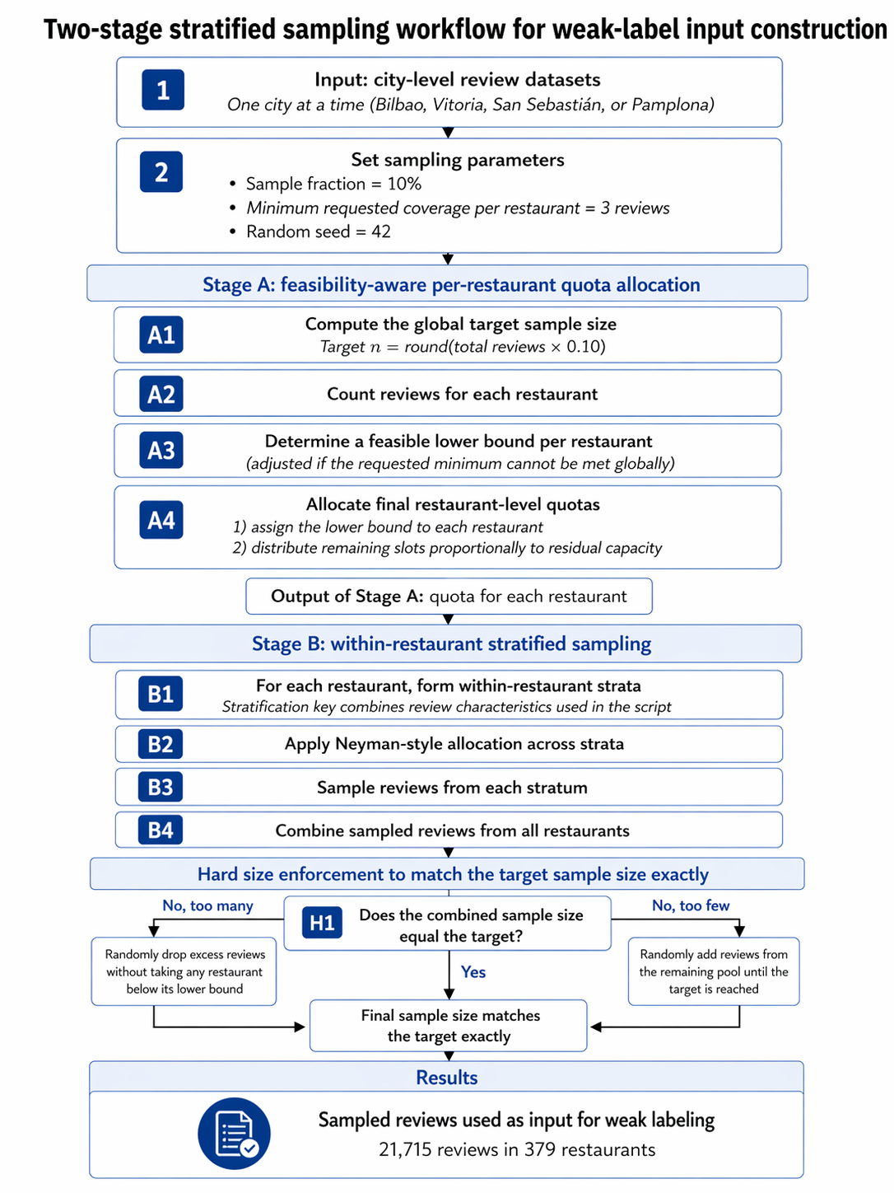
Figure 1 Two-Stage Stratified Sampling Workflow for Weak-label Input Construction.

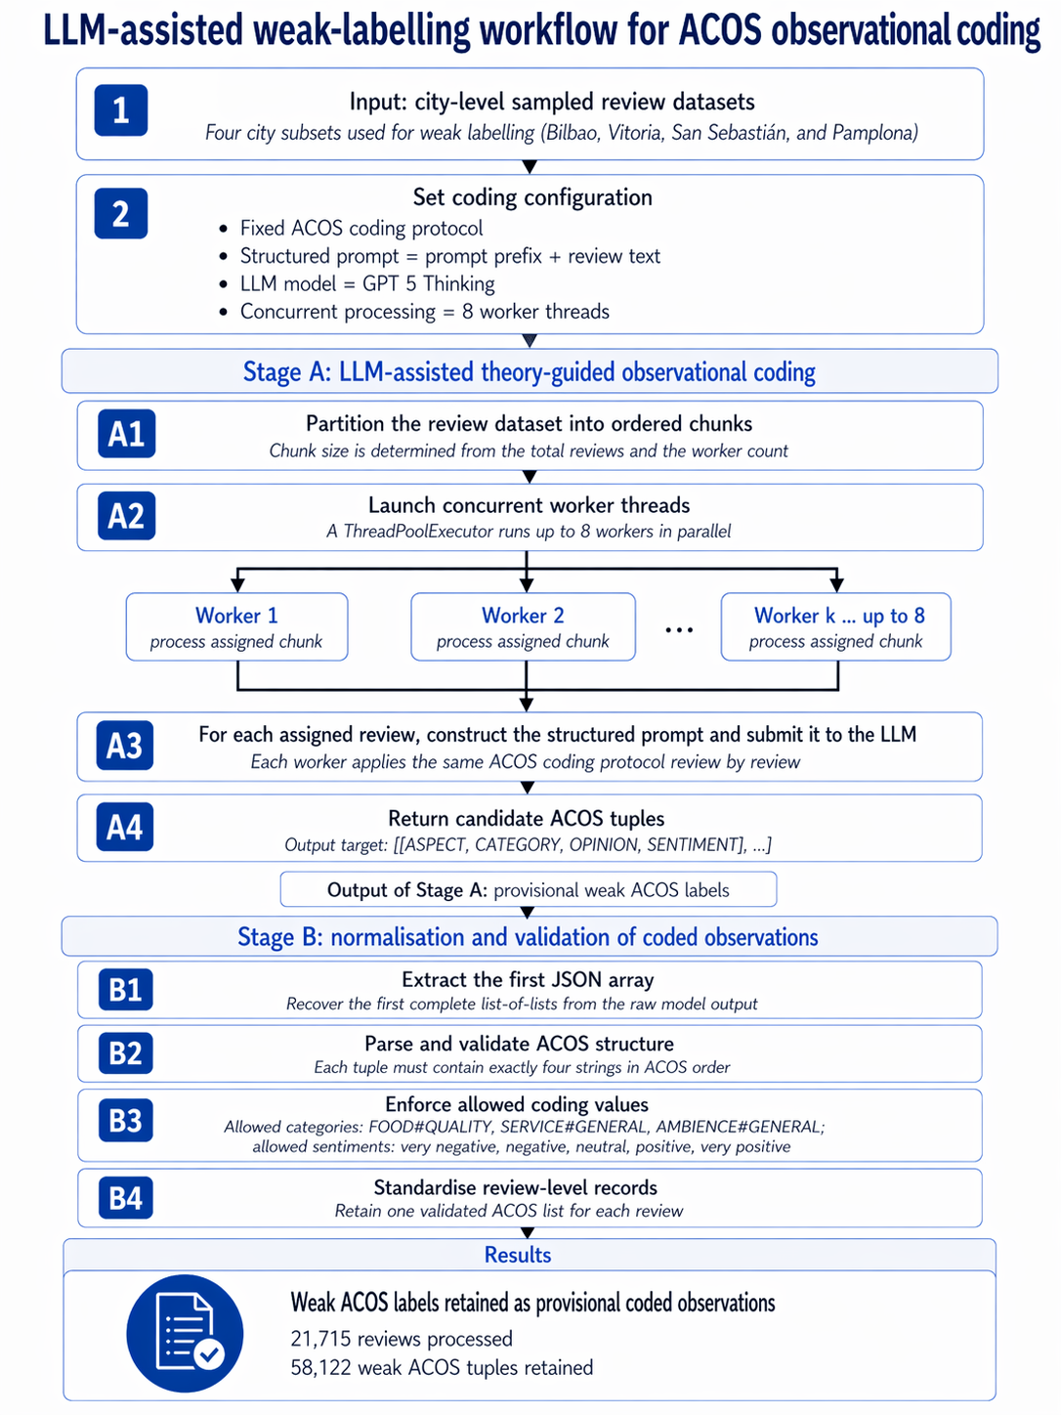
Figure 2 LLM-assisted Weak-labeling Workflow for ACOS Observational Coding.

